**Magnetic Induction: Faraday’s Law**

**Objective:** 1. Study Faraday’s law and induction

2. Understand sampling rate in measuring a time-varying signal.

**Introduction:**

When a magnet is passed through a coil, there is a changing magnetic flux *through* the coil that induces an electromotive force (*emf*) *in* the coil. According to Faraday’s law of induction,

(1)

where *V* is the induced *emf* in volts, *N* is the number of turns of wire in the coil, and is the rate of change of the flux (Φ) through the coil. The negative sign represents *Lenz’s law,* which states that an induced electromotive force (*emf*) always gives rise to a current whose magnetic field *opposes the original change* in magnetic flux.

These two laws are explored in this experiment by analyzing a graph of the *emf* vs. time (see Figure 1 for example), in which the area under the curve is found using Capstone. This area represents the flux (Φ) since (via rewriting equation 1)

(2)

where the induced voltage plotted as a function time will give that change of flux (V-s, or Wb) for a particular solenoid . **Part I** has you exploring these laws with the use of one solenoid and a magnetic bar going through the coil to induce a voltage, while **Part II** introduces two solenoids and serves as a precursor to building a transformer (**Part III**). A transformer is designed to change the amplitude of an AC voltage, usually in the form of a sinusoidal wave form. In an ideal transformer, the *rate of change* of the magnetic flux in the two coils is set *equal* so that a relationship between the amplitudes of the input and output wave can be derived via equation (1) as

(3)

The ratio of the turns makes either a step-up () or step-down () transformer. The ideal condition is usually approached by setting both coils on the same closed frame (of ferromagnetic material), which keeps the magnetic field inside the frame and passes through both coils. However, the field can leak from the frame, in which case the efficiency of the transformer has to be evaluated as,

(4)

where is defined as output.

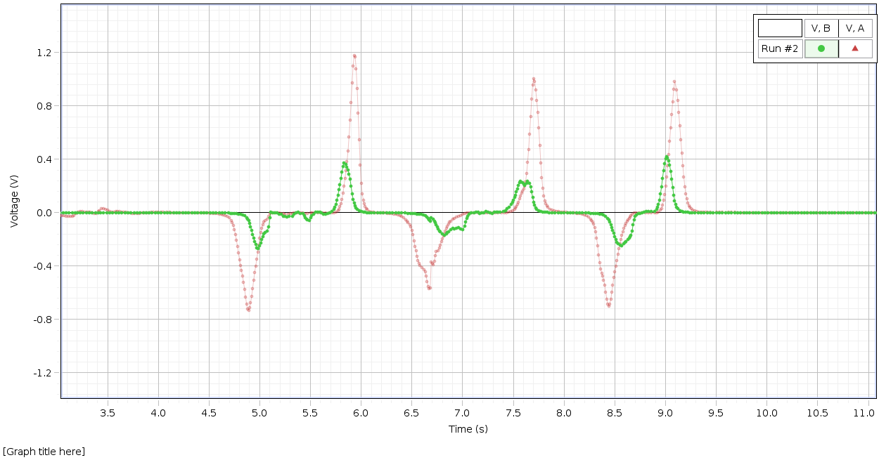

Figure 1. Induced *emf* (V) vs. time (s) for two solenoids.

**Experiment**:

* Equipment
  + *Solenoids* of various *N* values (i.e. 400, 800, 1600, etc.).
  + *Voltage sensor cable(s)*: these are used to connect the solenoid(s) to Capstone.

**NOTE: Capstone signifies red for positive charge and black for negative charge, and functions like a voltmeter.**

* + *Permanent magnetic bar*: used to induce a voltage in the coil.
  + *Iron frame*: this is used to connect two solenoids together in constructing a transformer.

**NOTE: you need to use the long screw to make a solid, closed frame.**

* + *Wave Function Generator*: a built-in wave generator in Capstone that sends out signals (i.e. square and sine waves) into devices/circuits (*see Appendix A*).

**NOTE: use of this is a precursor to the upcoming AC circuit labs.**

* Capstone Software
  + Used for recording the *V* vs. *t* plot and calculating the total area under the peak (*see Appendix B*).
* Basic Procedure

**Part I**

* + Select the solenoid with 1600 turns, connect it to *Channel A* in Capstone (see *Appendix A* for example, and don’t forget to select the “Voltage Sensor” icon for Channel A), select a sampling rate to gather good data, and observe by alternatively moving the magnetic bar fast/slow through the coil and flipping its polarization (N/S).
  + *Discussion: From your observations, what difference did you notice on the magnitude and sign of the induced voltage in the following cases? Use equation (1) to explain your results qualitatively.*
  1. *Put the south pole of the bar magnet slow/ fast into and out of the coil? Keep the magnet inside or outside the coil.*
  2. *Flip the pole of the magnet and try the same process again.*

**Part II**

* + Repeat the process of **Part I** but with two solenoids. Keep the coil with 1600 turns, pick the second one with 800 turns and connect it to Channel B. Place them together on the same axis so that you can insert and remove the bar magnet for both coils simultaneously. Plot emf voltages in both channels in the same plot as shown in figure 1.
  + *Discussion: answer/explain the same questions as in* ***Part I****.*

**Part III**

* + Assemble the two solenoids from **Part II** in the iron frame to construct the transformer (see Figure 2 for example). Connect one to the *Sine Wave* Generator and the other to Channel A . An input of 5V should be sufficient, and pick an input frequency between 10Hz to 1000Hz. Set your sampling rate accordingly (**Hint:** sampling rate~(25-50)\**frequency*). Plot both and on the same plot, and observe the waves.
  + *Discussion: How do the input and output voltages compare (likewise amplitude, phase, and frequency)? Do the and agree with equation (3)? If not, calculate the efficiency according to equation (4).*

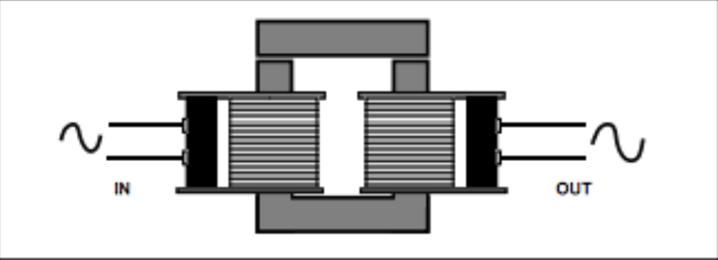

Figure 2. Setup for the transformer.

**Lab report requirement:**

* Standard lab report, but provide a complete analysis including answering all questions in **Parts I-III**.
* You decide the kind/amount of results (i.e. tables, plots) that will help strengthen your arguments.
* Be sure to include enough details in your tables/plots, and likewise be sure to cite your data/plots to support your conclusion.

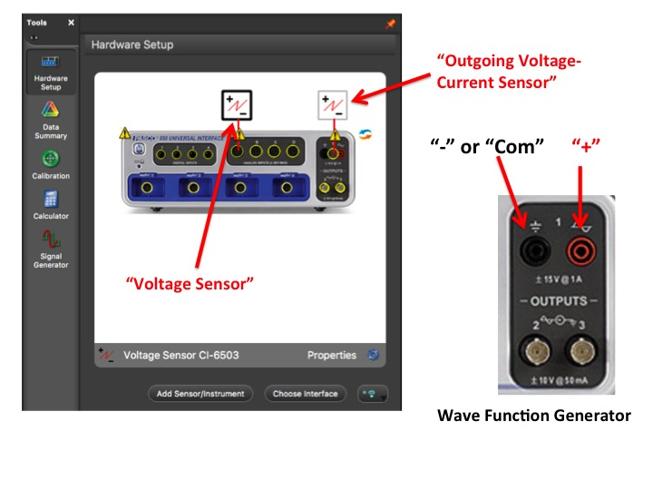**Appendix A: Preliminary Setup**

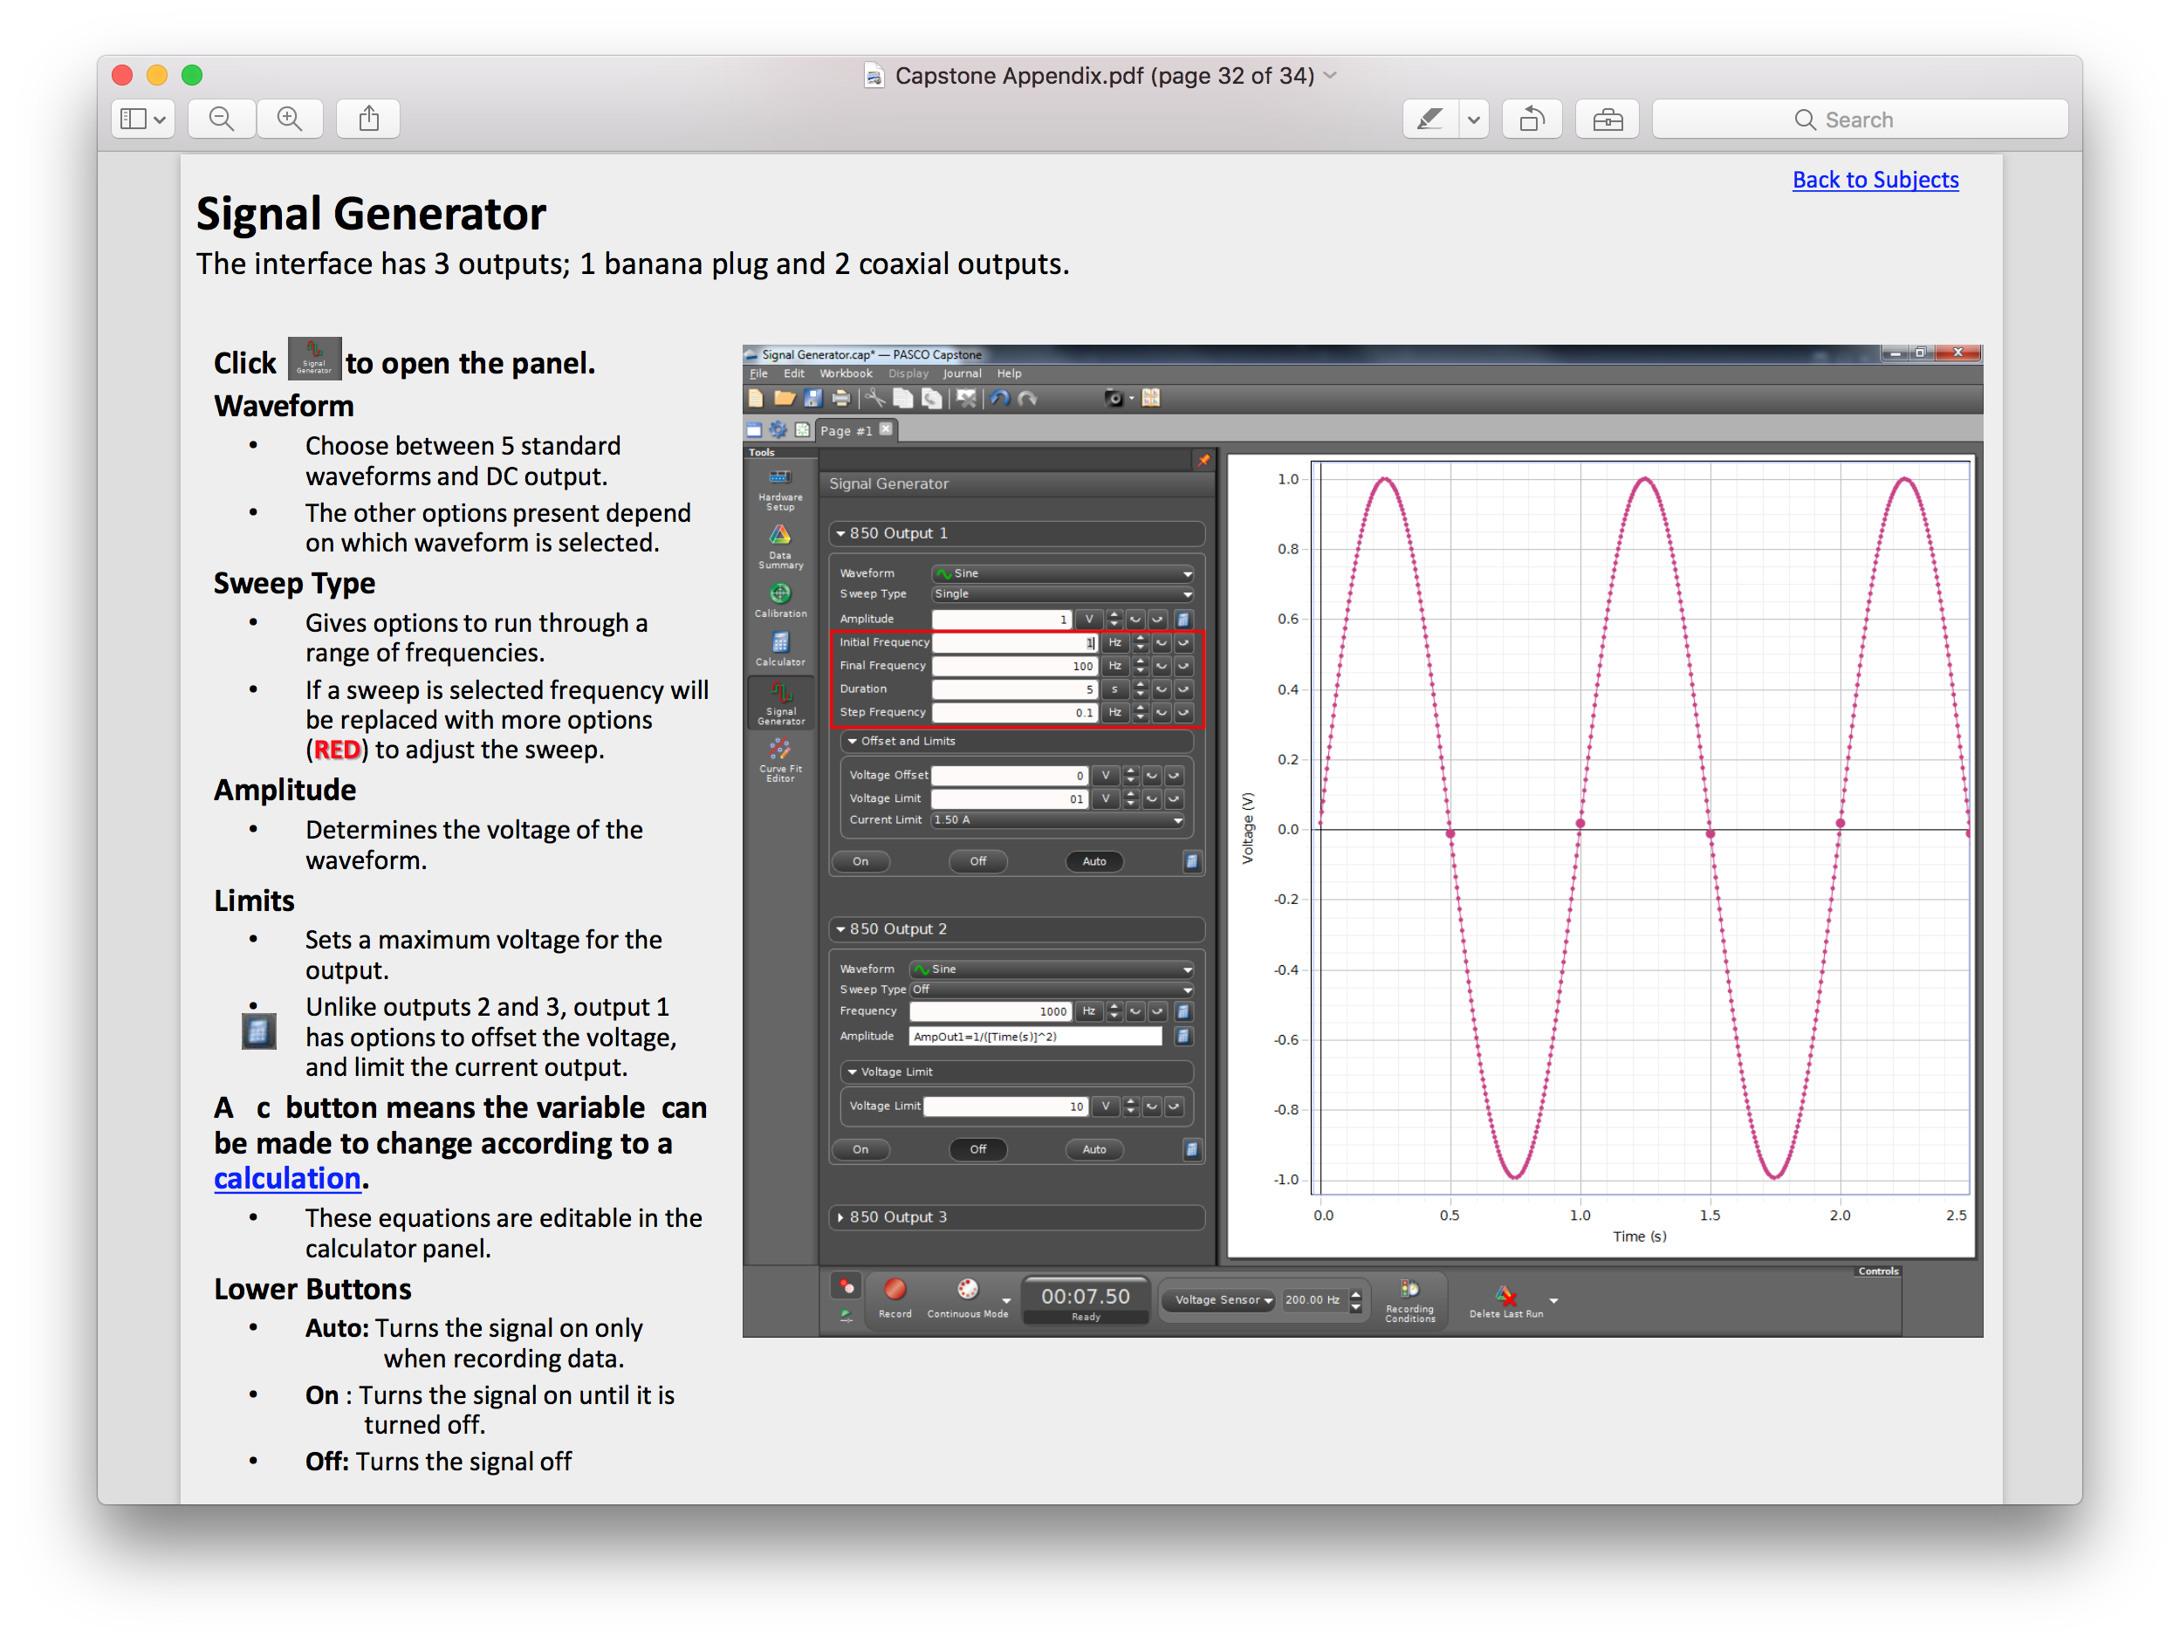

**Courtesy of a Capstone lecture from Virginia Tech: http://www.phys.vt.edu/~labs/CAPSTONE/Capstone%20Appendix.pdf**

**Appendix B: Data Analysis**

